CHAPTER 2: Getting into genes
Worksheet 2.2

DNA
Student: Class:

Nucleotides and DNA
1. The following images show a section of DNA and the composition of a nucleotide.
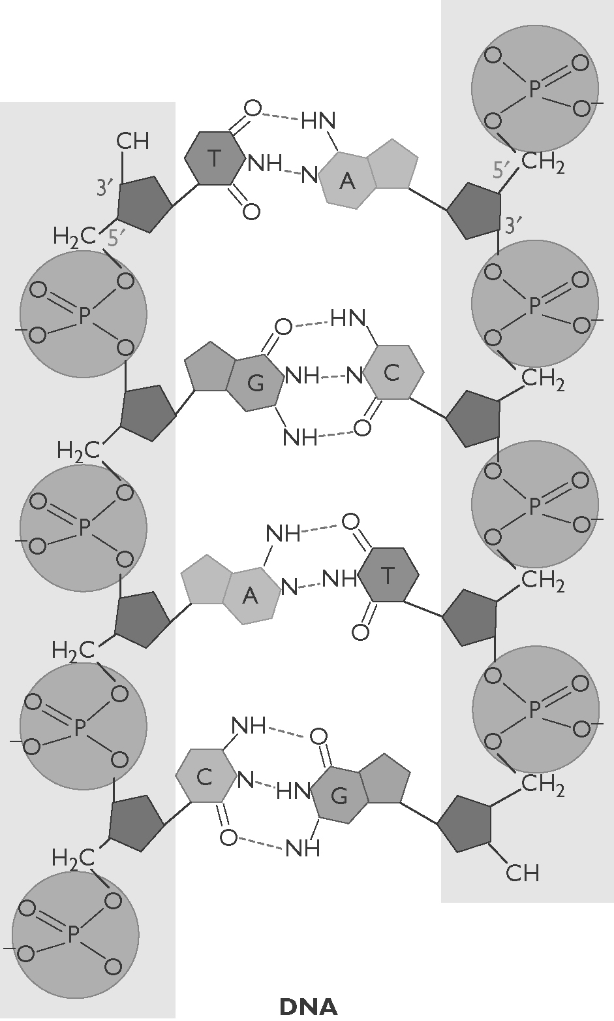 | 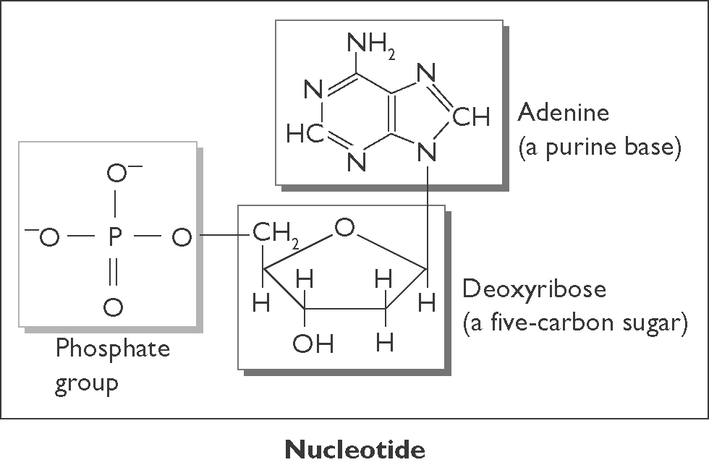  (a) Describe the structure of DNA in terms of nucleotides.  (b) Identify the molecules in the nucleotides that form the ‘backbone’ of the DNA ‘ladder’.
(c) State the pairing arrangement of the four types of nitrogen bases.

CHAPTER 2: Getting into genes
Worksheet 2.2

Page 2

Two-stranded DNA
2. The following diagram is a simplified section of the double-stranded DNA molecule.
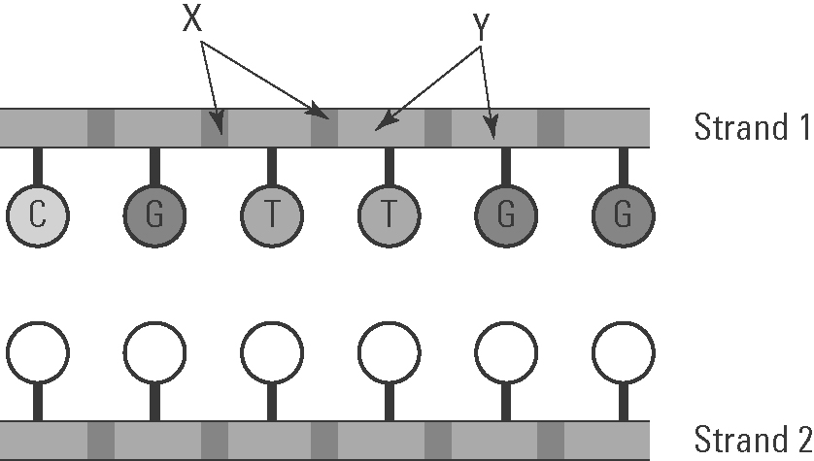 | (a) Identify components X and Y.  X: ............................................................  Y: ............................................................

(b) In strand 2 on the diagram, record the letters of the matching nucleobase (nitrogen base).

(c) What shape is a DNA molecule?

Guanine and cytosine
3. The structures of guanine and cytosine are shown below.
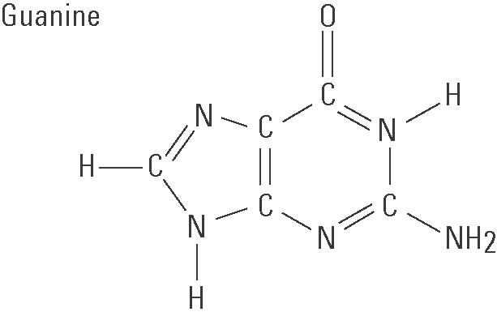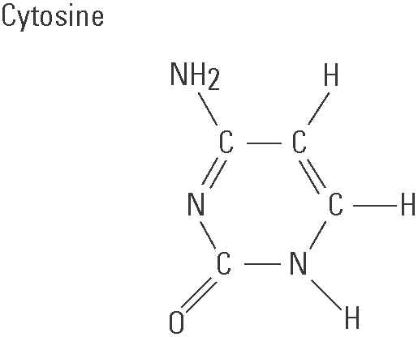

(a) Count the number of C, H, N and O atoms in each molecule.
Guanine:
C: ............ H: .............. N: .............. O: ............
Cytosine:
C: ............ H: .............. N: .............. O: ............
(b) Write the chemical formula for each molecule.
Guanine: ...........................................................
Cytosine: ..........................................................

